AI Learning Agent — Learning Journal
Phase 1: AI Agent Fundamentals
Progress documented from project setup through LLM Provider Factory
Purpose: This is the ongoing revision journal for the AI Learning Agent course. It captures the architecture, minimal theory, code changes, tests, and learning decisions. Future sessions can be appended to this same document.

1. Learning Goal and Approach
The goal is to understand how an AI agent is constructed, rather than simply learning how to call an AI API. We started with a simple application and progressively introduced tools, an agent, an LLM abstraction, provider configuration, and a provider factory.
- Use one application throughout the course.
- Frontend: React + TypeScript.
- Backend: Python + FastAPI.
- Start without a paid LLM API so the architecture is understood first.
- Build and test components independently before connecting them.
- Keep the UI simple while focusing on AI-agent concepts.
- Design for multiple LLM providers rather than coupling the Agent to one vendor.

2. Technology Stack
Area | Technology
Frontend | React + TypeScript
Backend | Python + FastAPI
HTTP client | Axios
Python environment | .venv
Configuration | python-dotenv + .env
Version control | Git + GitHub
Planned LLMs | OpenAI, Claude, Gemini

3. Architecture Evolution
Started with:
React → FastAPI → Router → Service → Mock response
Current architecture:
React
↓
FastAPI
↓
Chat Router
↓
Agent
↓
LLM Factory
↓
LLMService implementation
↓
Tool decision
↓
Tool Registry
↓
Tool Definition / Schema
↓
Calculator Tool

4. Project Structure So Far
AI-Learning-Agents/
├── backend/
│ ├── .env
│ ├── .venv/
│ └── app/
│ ├── main.py
│ ├── agent/
│ │ ├── __init__.py
│ │ └── agent.py
│ ├── config/
│ │ ├── __init__.py
│ │ └── llm_config.py
│ ├── routers/
│ │ ├── chat.py
│ │ └── health.py
│ ├── services/
│ │ ├── llm_service.py
│ │ ├── mock_llm.py
│ │ ├── openai_service.py
│ │ ├── claude_service.py
│ │ ├── gemini_service.py
│ │ └── llm_factory.py
│ └── tools/
│ ├── calculator.py
│ ├── registry.py
│ └── tool_definition.py
└── frontend/
└── React + TypeScript application

5. Day 1 — Foundation

5.1 React + FastAPI + CORS
React runs on localhost:5173 and FastAPI on 127.0.0.1:8000, so CORS was required.
allow_origins=["http://localhost:5173"]
allow_credentials=True
allow_methods=["*"]
allow_headers=["*"]

5.2 Chat Router
The chat endpoint was moved into a router so HTTP concerns stay separate from AI logic.
GET /chat?message=Hello
return {"response": agent.run(message)}

5.3 Initial AI Service
The first service was deliberately a mock response. This gave us a stable backend before introducing an actual LLM.
class AIService:
def chat(self, message: str):
return f"AI says: You entered '{message}'"

6. Calculator Tool
A tool is a capability that the agent can execute. We selected a calculator because it is deterministic and easy to test.
def calculate(a: float, operator: str, b: float) -> float:
if operator == "+":
return a + b
if operator == "-":
return a - b
if operator == "*":
return a * b
if operator == "/":
if b == 0:
raise ValueError("Cannot divide by zero")
return a / b
raise ValueError(f"Unsupported operator: {operator}")
Example: calculate(25, "+", 75) → 100

7. Error Handling
Malformed calculations and division by zero are caught so the application returns a useful error instead of an uncontrolled server exception.
try:
result = calculate(...)
except ValueError as error:
return f"Calculation error: {error}"

8. Tool Registry
The Tool Registry centralizes available tools. The Agent asks the registry for a tool by name instead of importing every tool directly.
tool = registry.get_tool("calculate")

9. Tool Definition
Each tool was given metadata: name, description, parameters, and function. This prepares the tool for LLM tool calling.
ToolDefinition:
name
description
parameters
function

10. Tool Schema
A to_schema() method converts the internal Python definition into a model-friendly dictionary.
return {
"name": self.name,
"description": self.description,
"parameters": {
"type": "object",
"properties": self.parameters,
"required": list(self.parameters.keys()),
},
}

11. First Agent
The Agent owns the workflow. Initially its decision was rule-based, such as checking whether the message started with 'calculate'. This was intentionally done before adding an LLM.
User → Agent → Tool Registry → Calculator → Result

12. Mock LLM
MockLLM was created to simulate an LLM without API cost. It can return a tool_call decision or a final_response.
Example:
{
"type": "tool_call",
"tool": "calculate",
"arguments": {"a": 125, "operator": "+", "b": 350}
}
This made the complete agent loop understandable before using a real LLM.

13. LLM Service Abstraction
An abstract LLMService contract was introduced. Every provider must implement decide(message).
class LLMService(ABC):
@abstractmethod
def decide(self, message: str) -> dict:
pass
The Agent therefore depends on a capability/contract, not directly on OpenAI.

14. Dependency Injection
The Agent was changed to accept an LLM from outside. If none is supplied, MockLLM is used.
Agent(llm=...)
Later:
Agent(OpenAIService())
Agent(ClaudeService())

15. Multi-LLM Configuration
Provider configuration was created before using any real API. Enable flags and API keys are read from environment variables.
Example .env:
OPENAI_ENABLED=false
OPENAI_API_KEY=
ANTHROPIC_ENABLED=false
ANTHROPIC_API_KEY=
GOOGLE_ENABLED=false
GOOGLE_API_KEY=
Security rule: never hard-code API keys and never commit .env to GitHub. The .env file is excluded through .gitignore.

16. Provider Services
- OpenAIService → LLMService
- ClaudeService → LLMService
- GeminiService → LLMService
These classes currently contain the provider configuration and a placeholder decide() method. Actual API integration comes next.

17. LLM Provider Factory
LLMFactory selects a provider and enforces configuration guardrails.
LLMFactory.create("mock") → MockLLM
LLMFactory.create("openai") → OpenAIService only when enabled and key exists
LLMFactory.create("anthropic") → ClaudeService only when enabled and key exists
LLMFactory.create("google") → GeminiService only when enabled and key exists
At this stage OpenAI, Claude, and Gemini are disabled. Testing a disabled provider correctly raises a configuration error.

18. What We Have Learned
- React handles the UI.
- FastAPI exposes backend APIs.
- Routers handle HTTP/API concerns.
- Services contain reusable application capabilities.
- An Agent owns the workflow/decision loop.
- A Tool is a capability the Agent can execute.
- A Tool Registry centralizes available tools.
- Tool Definitions describe capabilities.
- Tool Schemas provide machine-readable tool metadata for an LLM.
- MockLLM allows agent development without API cost.
- LLMService prevents the Agent from being tied to one vendor.
- Dependency injection makes the LLM implementation replaceable.
- A Provider Factory centralizes provider selection and configuration checks.
- API keys belong in environment/secret storage, not source code.

19. Current Status
Capability | Status | Next
React + TypeScript | Complete | Keep UI simple
FastAPI + CORS | Complete | Continue API work
Chat Router | Complete | Keep HTTP concerns separate
Calculator Tool | Complete | Add tools later
Tool Registry | Complete | Register future tools
Tool Definition + Schema | Complete | Use with real LLM
Mock LLM | Complete | Keep for tests
LLM abstraction | Complete | Use for all providers
Provider configuration | Complete | Enable providers when ready
Provider services | Complete structurally | Implement real APIs
Provider Factory | Complete | Select enabled provider
Real OpenAI integration | Next | Install SDK + API key
Real tool calling | Next | LLM selects calculator
Agent loop | Next | LLM → tool → result → LLM
Memory | Later | Add conversation/context memory

20. Revision Questions
- What is the responsibility of the Router?
- What is the responsibility of the Agent?
- What is a Tool?
- Why do we need a Tool Registry?
- Why does a Tool need a schema?
- Why did we create MockLLM?
- Why does Agent depend on LLMService instead of OpenAIService?
- What does dependency injection give us?
- Why are provider enable flags and API keys configuration concerns?
- What will the real LLM decide in the next stage?

21. Git Learning
The initial project was pushed to GitHub. Feature branches are being introduced for future work.
Typical workflow:
git switch -c feature/<feature-name>
git add .
git commit -m "feat: <description>"
git push -u origin feature/<feature-name>

22. Next Learning Milestone — Real OpenAI Agent
Next we will implement OpenAIService, configure the OpenAI API key securely, and let the LLM choose whether to call the calculator. The expected flow is:
User: "What is 125 plus 350?"
↓
OpenAI
↓
Tool call: calculate(a=125, operator="+", b=350)
↓
Calculator
↓
475
↓
OpenAI
↓
"The answer is 475."

23. How We Will Continue This Document
This document should remain the single revision journal for the course. Each future milestone will be appended with: goal, minimal theory, architecture flow, code changes, tests, lessons learned, and the updated architecture. This keeps the entire journey from beginner setup to the completed targeted course in one place.
CURRENT MILESTONE COMPLETE — NEXT: REAL OPENAI INTEGRATION

24. Current Milestone — Real Gemini Integration
What changed: We moved from the MockLLM/rule-based tool decision to a real Gemini LLM. Gemini now receives the calculator tool definition and decides whether a tool call is appropriate.

24.1 Minimal Theory
- The MockLLM previously used application code/rules to decide when to call the calculator.
- Gemini now understands the user's intent and selects an available tool based on the tool name, description, and parameter schema.
- Gemini does not execute our Python calculator. It returns a structured tool call. The Agent is responsible for finding and executing the Python tool.
- This creates the core separation: Gemini decides → Agent orchestrates → Tool executes.

24.2 Gemini Tool Declaration
GeminiService defines the calculator as a Gemini FunctionDeclaration. The declaration describes the capability and its inputs; it is not the Python function itself.
calculate_tool = types.FunctionDeclaration(
name="calculate",
description="Perform a mathematical calculation.",
parameters=types.Schema(
type="OBJECT",
properties={
"a": types.Schema(type="NUMBER", description="First number."),
"operator": types.Schema(
type="STRING",
description="Mathematical operator: +, -, *, or /."
),
"b": types.Schema(type="NUMBER", description="Second number."),
},
required=["a", "operator", "b"],
),
)

24.3 Gemini Decision
For a request such as "Calculate 125 + 350", Gemini returned a structured decision similar to:
{
"type": "tool_call",
"tool": "calculate",
"arguments": {
"a": 125,
"b": 350,
"operator": "+"
}
}

24.4 Agent Executes the Tool
The Agent receives Gemini's decision, asks ToolRegistry for the requested tool, and executes the Python function using the returned arguments.
decision = self.llm.decide(message)
tool_name = decision["tool"]
arguments = decision["arguments"]
tool = self.tool_registry.get_tool(tool_name)
result = tool.function(**arguments)
For the example above, the calculator executes calculate(125, "+", 350) and returns 475.

25. User-Selectable LLM Provider
We decided that the user should be able to choose which LLM provider is used. The Chat API therefore passes the provider to the Agent, and the existing LLMFactory creates the appropriate provider service.
@router.get("/chat")
def chat(
message: str,
provider: str = "gemini",
):
agent = Agent(provider=provider)
return {
"provider": provider,
"response": agent.run(message),
}

25.1 Provider Selection Flow
The same Agent and tool architecture can now work with Gemini, OpenAI, or Claude. The provider-specific service is selected by LLMFactory.
Conceptual flow:
User selects provider → FastAPI /chat receives message + provider → Agent(provider) → LLMFactory → GeminiService/OpenAIService/ClaudeService → Agent → Tools

25.2 Why We Are Not Refactoring Tool Adapters Yet
We intentionally decided not to introduce a generic LLM-provider tool adapter while only one calculator tool exists. When a second real tool is added, we will revisit the design and remove any genuine duplication. This follows the learning principle: start simple, identify real duplication, then refactor.

26. Current Agent Architecture — Visual
The following diagram represents the current architecture with user-selectable LLM providers.
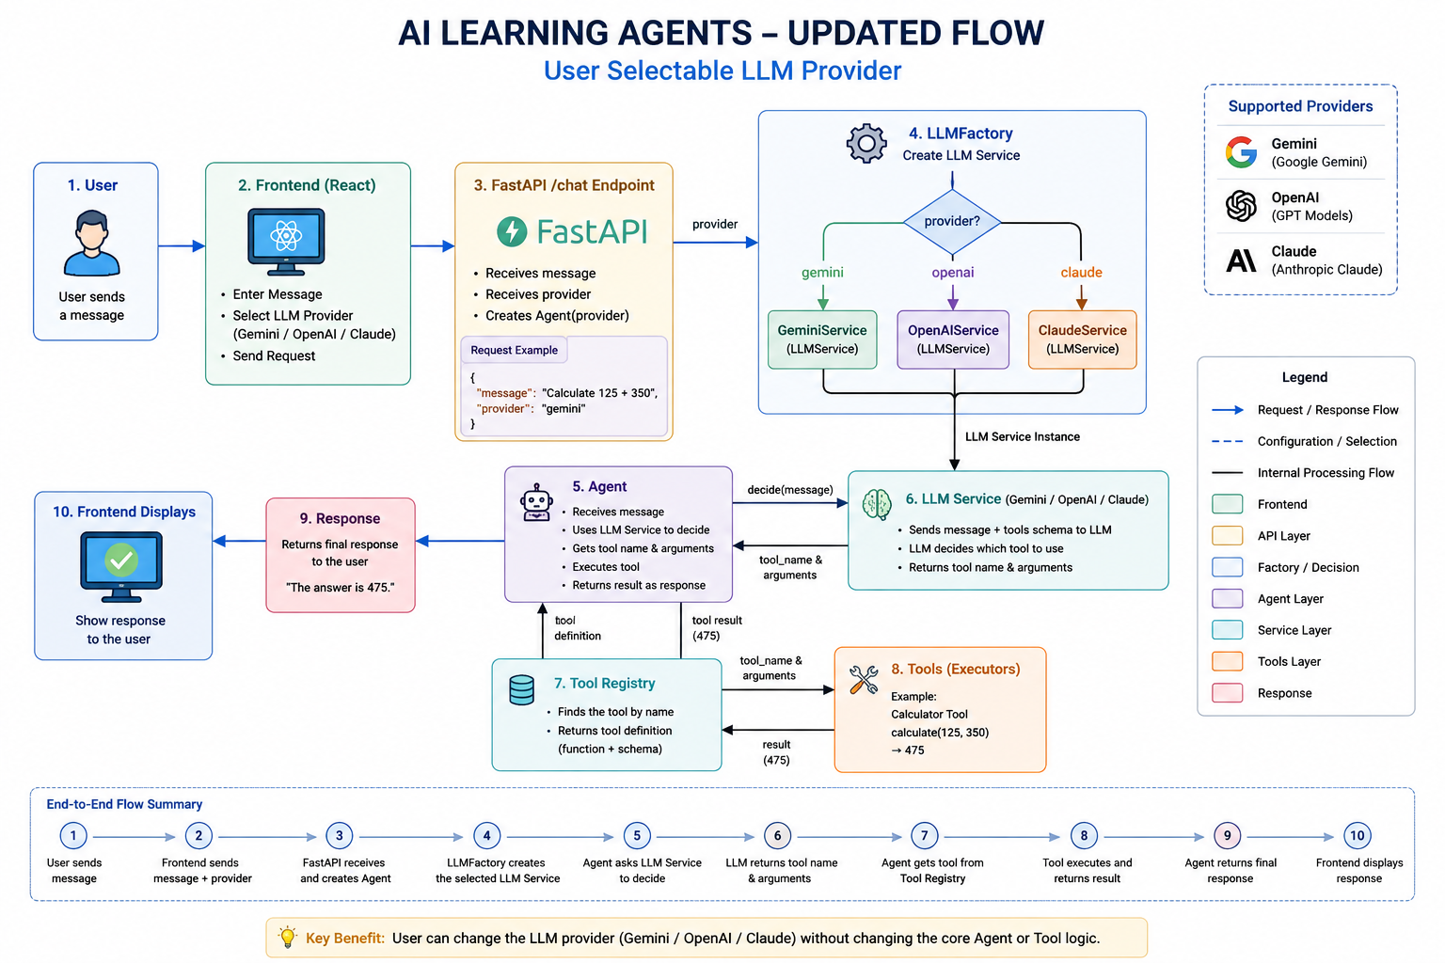

27. Debugging the Real Python Flow
We configured VS Code/Antigravity debugging so the real execution path can be observed instead of only reading diagrams.
- The debugger must use backend/.venv/Scripts/python.exe rather than the global Python installation.
- FastAPI is launched through Uvicorn with the project virtual environment.
- Breakpoints can be placed in chat.py, agent.py, gemini_service.py, and calculator.py.
- F10 (Step Over) executes the current line; F11 (Step Into) enters the called function; Shift+F11 steps out.
Recommended breakpoints:
chat.py
def chat(message: str):
agent.py
decision = self.llm.decide(message)
tool = self.tool_registry.get_tool(tool_name)
result = tool.function(**arguments)
gemini_service.py
response = self.client.models.generate_content(...)
if response.function_calls:
calculator.py
def calculate(...):

27.1 Debugging Journey
HTTP request → Chat Router → Agent.run() → GeminiService.decide() → Gemini tool call → Agent → Tool Registry → Calculator → result → Agent → HTTP response

28. Updated Learning Summary
- Gemini can select a tool from its declaration without us writing an if-condition for every natural-language variation.
- A tool declaration describes a capability; it does not execute the Python function.
- The Agent remains responsible for tool lookup and execution.
- LLMService keeps the Agent independent of a specific LLM vendor.
- LLMFactory allows the provider to be selected without changing the Agent's orchestration logic.
- The user can now choose Gemini/OpenAI/Claude at the API boundary.
- Debugging lets us observe the real runtime flow and inspect message, decision, tool name, arguments, tool object, and result.

29. Updated Next Learning Milestone
Next: complete the full agent tool-calling loop so the tool result is sent back to the LLM for a final natural-language response. After that, add another tool and use the real duplication as the reason to introduce a provider-neutral tool-to-LLM adapter. Then implement OpenAIService and allow the same Agent to work with OpenAI.
CURRENT MILESTONE: REAL GEMINI TOOL SELECTION + USER-SELECTABLE PROVIDER + DEBUGGING FLOW

